**Lecture: 3. Introduction to .NET Memory Management**:

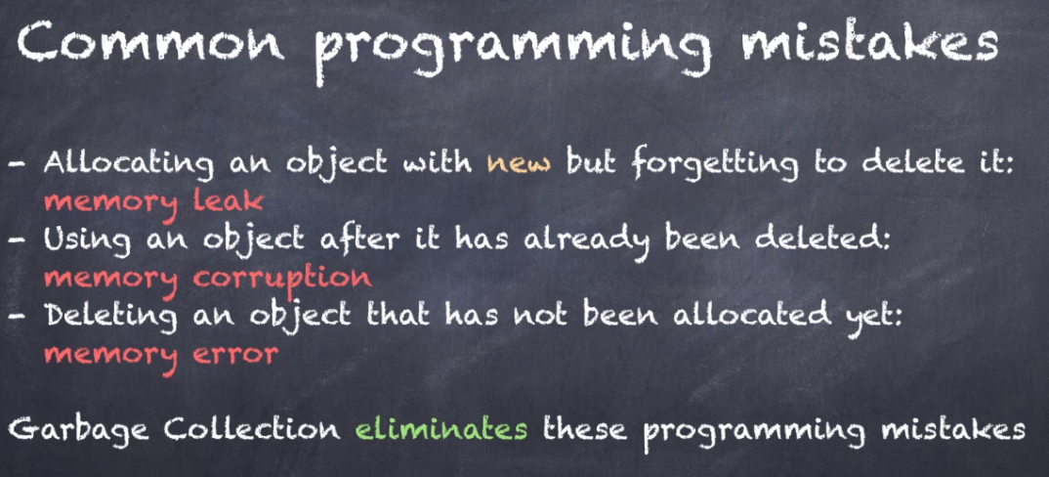

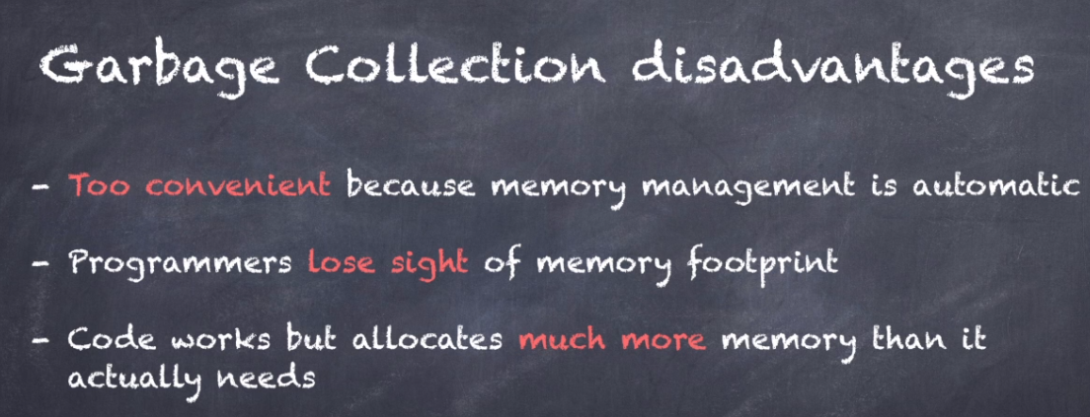

**Lecture: 7. The Stack:**

Initially Stack will be empty, but when our code calls method this happens(below) the method parameters, the return address and all local variables of the methods are put on the stack. This whole block of data is called stack frame.

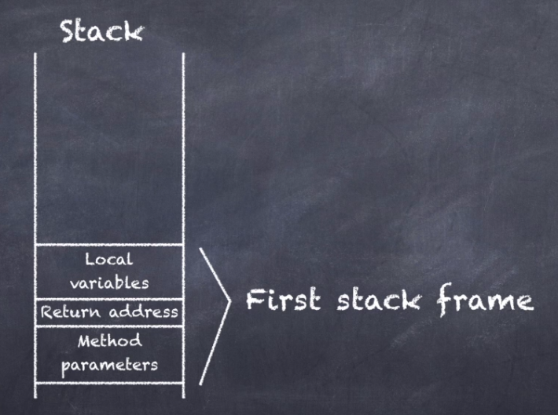

So, what happens to the stack when my code calls in other methods from inside this method. What's this the same thing happens again.

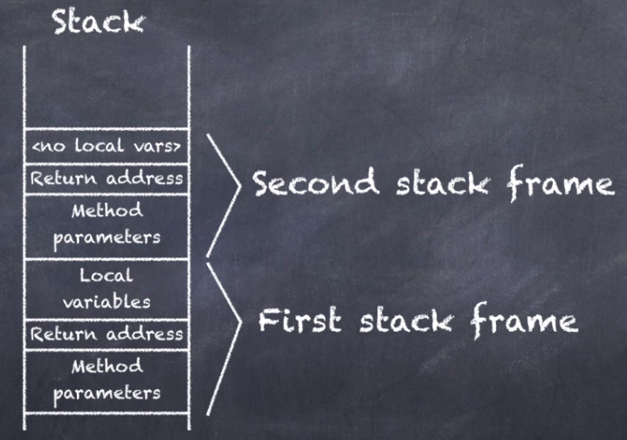

The method parameters return address and local variables of the new method. I put on the stack right on top of the previous stack frame.

So, therefore it's called the stack information is stacked on top of one another.

What happens when my code encounters return statements?

As you probably know the return statements ends the methods and returns to the calling code.

Now on the stack this is what happens the entire stack frame that corresponded to the method is removed.

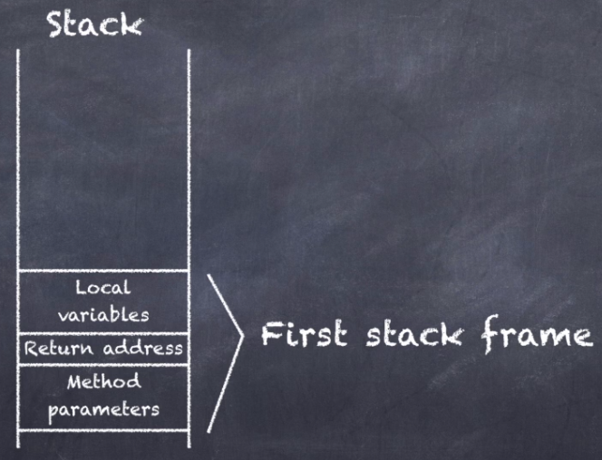

But you might be thinking what happened to all the local variables stuff was stored in the stack frame.

Well they all go out of scope which is just a fancy way of saying that they are destroyed.

So, this is an important fact to remember the moment you return for methods all your local variables of that methods go out of scope and are destroyed.

If I continue my program and also return out of the first methods, we are back to where we started with an empty stack



you might be wondering what happens if a method calls another method which calls another method which

calls and other methods a thousand times.

Well the stack would quickly fill up with stack frames until there is no more room.

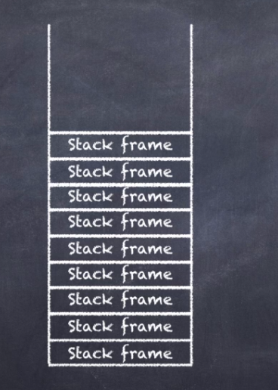

Eventually the stack will be completely full and the Dot Net Framework throws Stack Overflow exception.

If you see this error message it means you have an infinite sequence of method calls. somewhere in your code

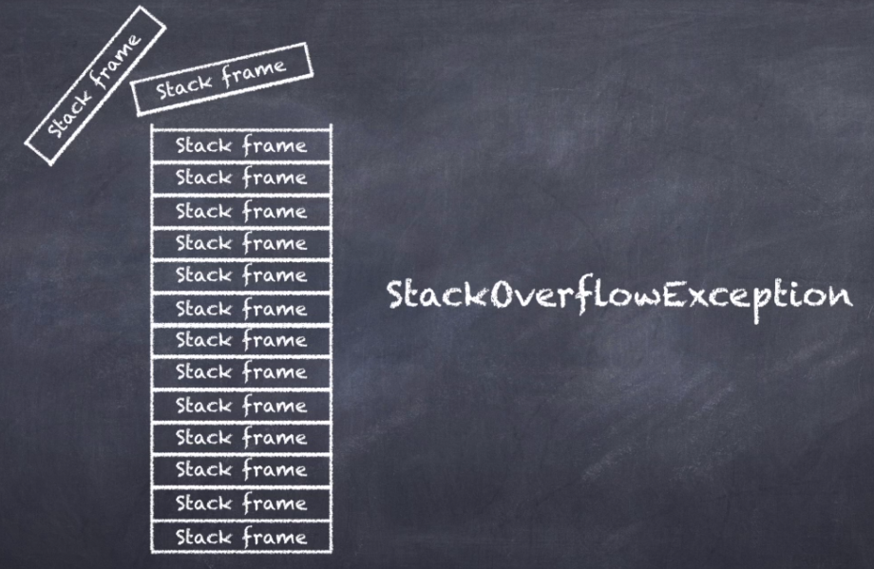

I've modified my code. So now draw a line calls into a draw line which then calls into a line which calls to draw a line. This sequence will never end.

When I run this program, it will create an infinite sequence of draw line methods calling themselves must run the program and see what happens. And there you have it.

If I have too many methods calling other methods eventually the stack will be completely full of the dot net framework froze the stack overflow exception.

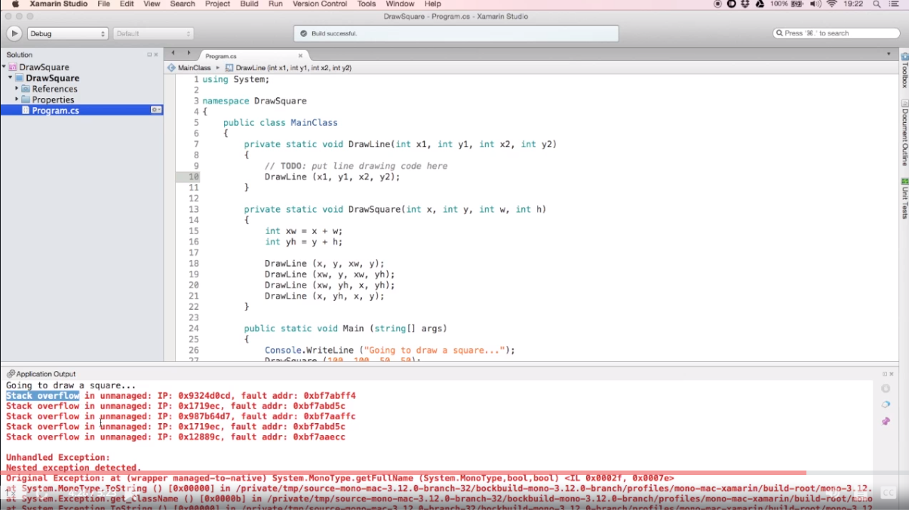

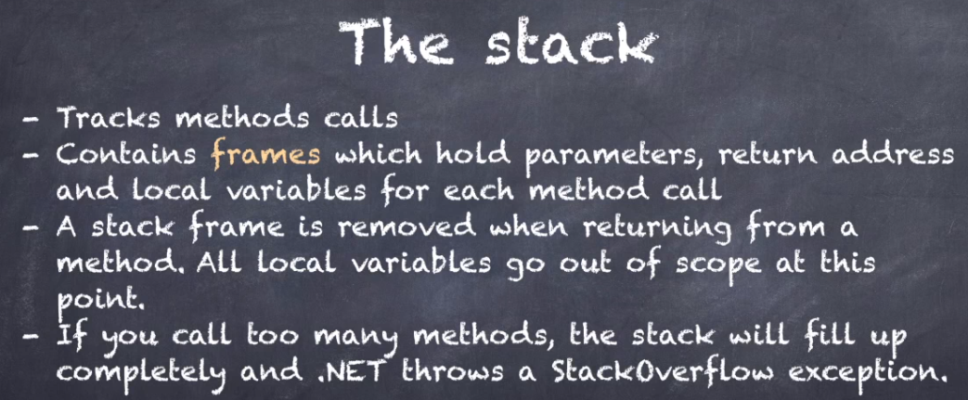

So, what have we learned? The framework uses the stack to track method calls every time you call a method or if its method parameters the return address and all local variables are placed on the stack.

This entire block of memory is called a stack frame when you return out of a massive the top stack frame is removed all local variables go out of scope at this point and destroys if you have an infinite sequence of methods calling other methods the stack will fill up completely and .net will throw a stack overflow.

**Lecture: 8. The Heap:**

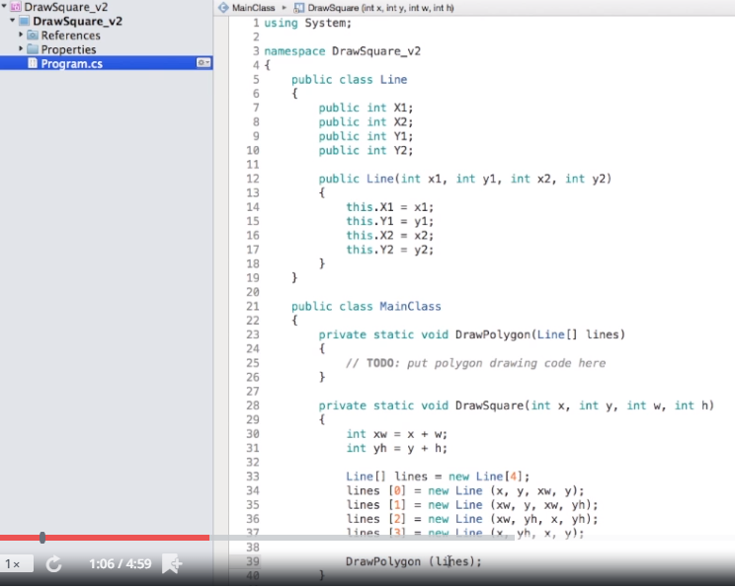

So, what are the stack and the heap going to look like now. The parameter calls and lines exists on the stack because it's a parameter, but I initialized it with the new keywords. So, the array itself is created on the heap.

So, the variable on the stack refers to an object on the heap. You can also see that the lines are array for elements and that each element refers to a line object elsewhere on the heap.

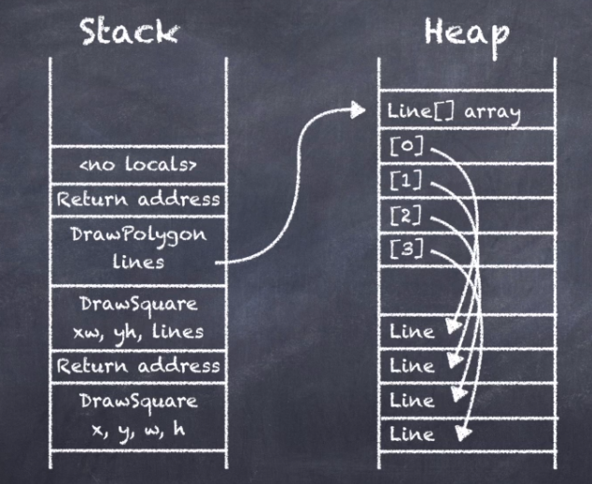

So now what happens when the draw polygon method finishes the stack frame is removed and the line parameter goes out of scope and is destroyed. But here is something you might not have expected.

The array and the line objects on the heap continue to exist. Now this is an interesting situation. The line parameter is out of scope but the objects on the heap are still there.

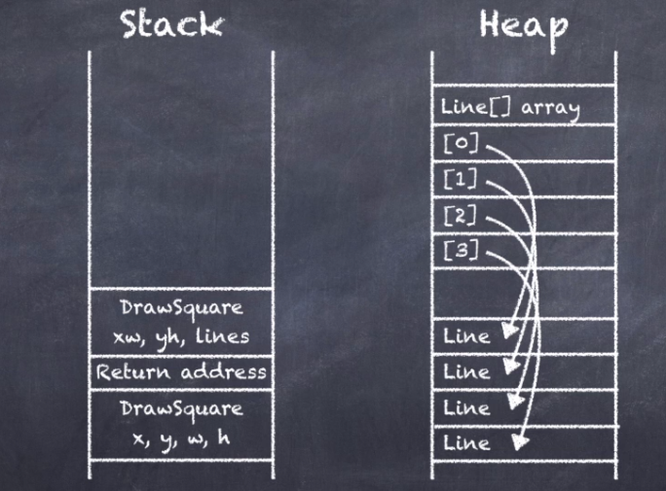

We say that the objects are dereferenced because of the variable or parameter that refer to them with out of scope. Dereferenced objects continue to exist and are not destroyed immediately. So here is another important takeaway.

The Dot Net framework will always postpone cleaning up dereferenced objects and this is because cleaning up the heap takes a lot of time and by postponing it for as long as possible. Your code will actually run faster.

But eventually the framework will have to clean the heap, or we would quickly run out of memory. This cleaning process is called garbage collection and it happens periodically in the background.

When the framework starts garbage collecting it identifies all objects on the heap which are no longer referenced by any variable parameter or objects in your code and it deallocates each of them.

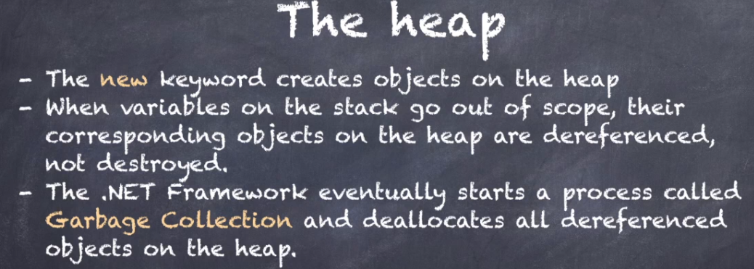

**Lecture: 9. Value Types:**

Let's take a closer look at an integer in the Dot Net Framework. The integer type is part of a special class of types called value types. But what is a value type of value tied is a type of variable where the type and the value of the variable stores together.

So, if I have a local integer variable with a value of 1234 that integer type then its value will be stored together like this.

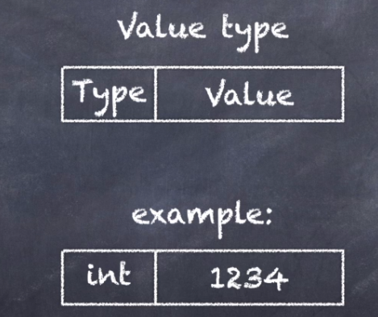

So, let's look at the stack again.

Previously when I talked about the stack, I mentioned all types of data that are stored on the stack. They are method parameters, The return address of a method and local variables.

So, if you have a local variable of type integer with a value of 1234 it would be stored on the stack like this. You see that the type and the value stored together on the stack.

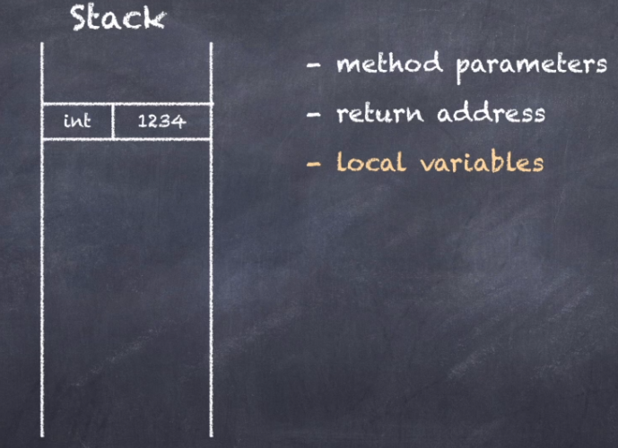

All numeric types are value types including all the integer, floating points and decimal types. Also, Booleans, enumerations and structures are value types.

Anything else in the Dot Net framework is called a reference type which I will discuss shortly.

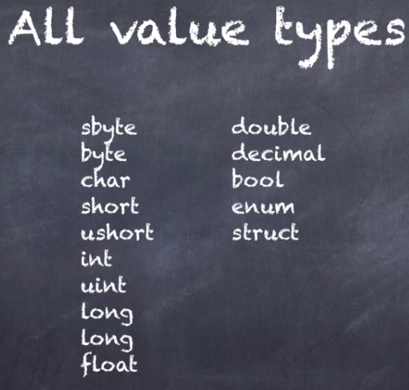

When people try to explain the difference between a value type and a reference type you often hear the following explanation.

“A valued side is a type that exists on the stack” However this is wrong.

s

“Value types can exist both on the stack and the heap.”

Here let me demonstrate previously when I talked about the heap, I mentioned what kind of data is stored on the heap. Do you remember what it was it was all object instances created with the new keyword in C#?

So, imagine that I create an object on the heap using the new keyword in my code and this object has one integer fields containing the value 1234. Now this integer will be stored like this.

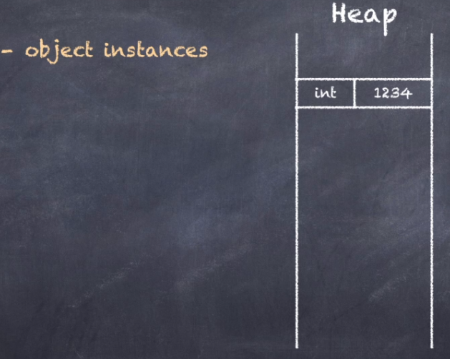

“So, you see now we have a value type on heap. So, value types can exist on both stack and on the Heap. The defining property of value types is not where they are stored but that the value is stored together with the type.”

Important Feature:

Let's say I have a method in my code with two variables A and B both are integers.

The variable A contains the value 1234 and the variable B is zero.

Now what happens when I assign A to B. Check this out.

The value of A is copied into B.

Now this is an important feature of value types. They are assigned by value which means their value is copied over.

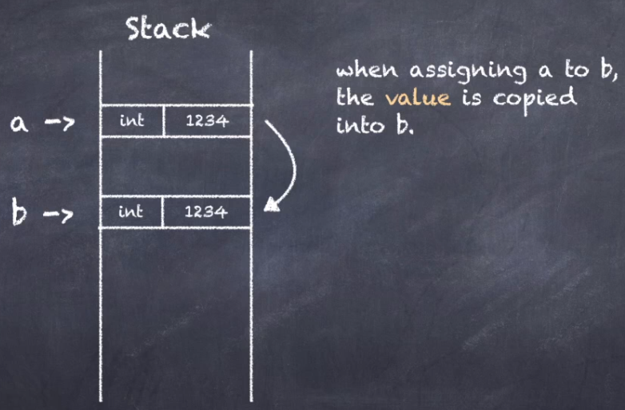

So, then what happens if I compare A and B.

They are two different variables that just happened to contain the same value.

So how will the Dot Net Framework interpret the situation well like this:

The framework considers these two variables to be equal.

This is the second important feature of value types.

“They are compared by value which means two different variables holding the same value are considered equal.”



**Lecture: 10. Reference Types:**

what is a reference type Well a reference type is a type of variable that refers to a value stored on the heap?

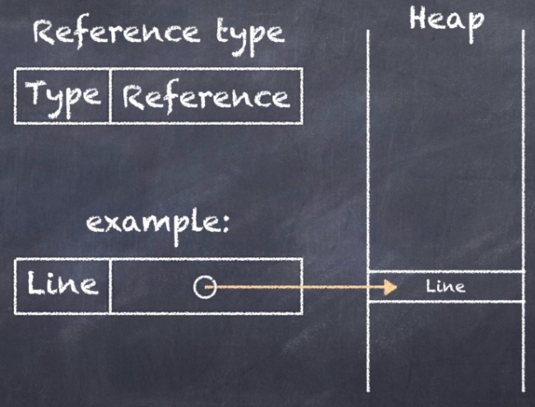

You can see the definition of the line class. Here it's a simple data container with two sets of coordinates. So, imagine I have a method with a local variable of type line.

What would that look like in memory. Well like this:

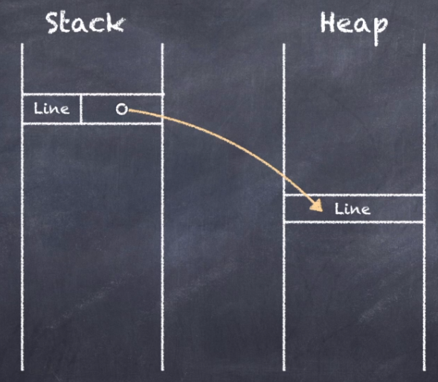

You can see that the variable itself is on the stack, but it refers to a line object on the heap.

But can a reference type variable also exist on the heap. Yes sure.

Well I need to do is create an object on the heap using the new keywords and have that objects one fields of type line.

Now the memory will then look like this:

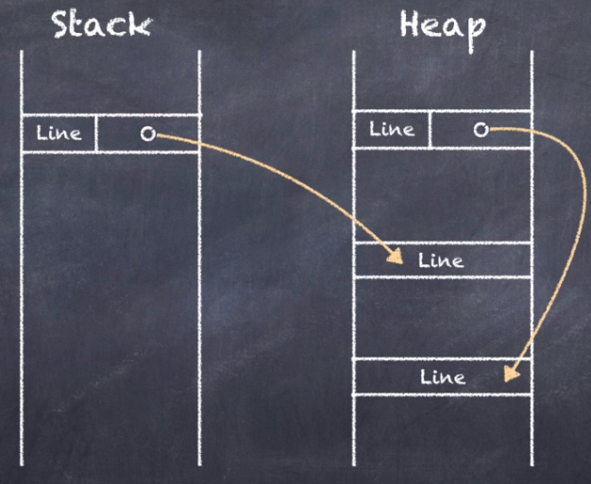

You see that I now have a reference type variable on the heap, and it refers to a line object which is also stored on the heap but elsewhere.

So, to summarize reference types can exist on the stack and on the heap just like value types but they will always refer to a value on the heap.

Let me finish by showing you two important additional features of reference types.

Let's say I have a method in my code with two variables A and B both variables are lines. The variable a refers to a line instance on the heap and the variable b is said to know now what happens when I assign a to b.

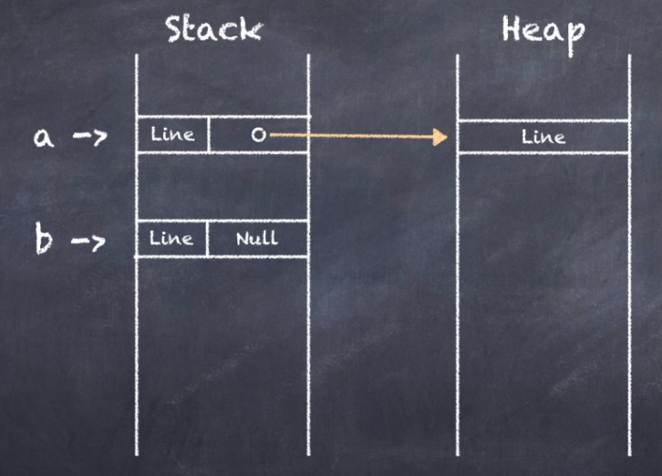

Check this out.

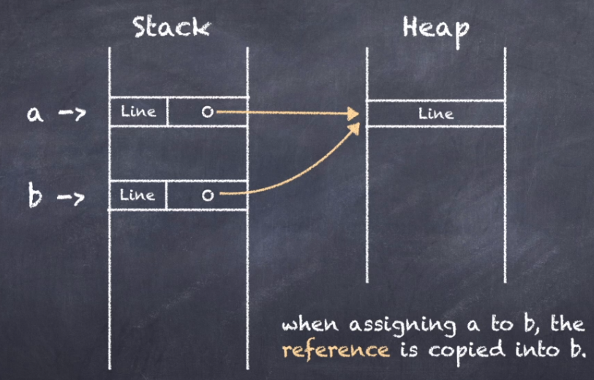

The reference of a is copied into B. This is an important feature of reference types.

They are assigned by reference which means that the reference is copied over. You end up with two variables referring to the same object instance on the heap.

So, know what happens when I compare a and b.

They are two different variables that refer to the same objects on the heap.

How will the Dot Net Framework interpret this situation?

Well like there's the framework considers these two variables to be equal.

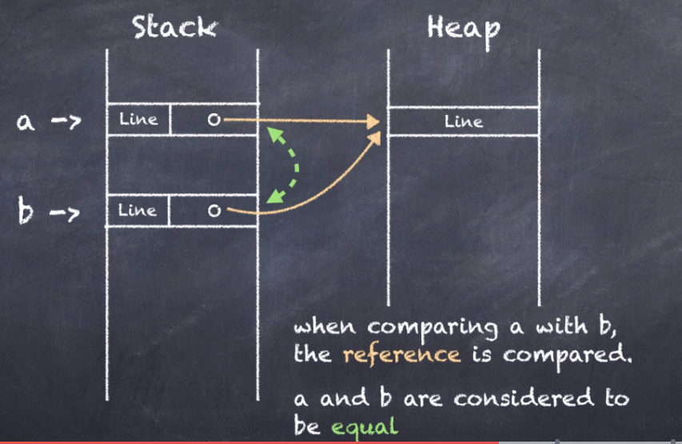

But wait what about this scenario. To reference type variables pointing to two separate objects on the heap but both objects contain identical data.

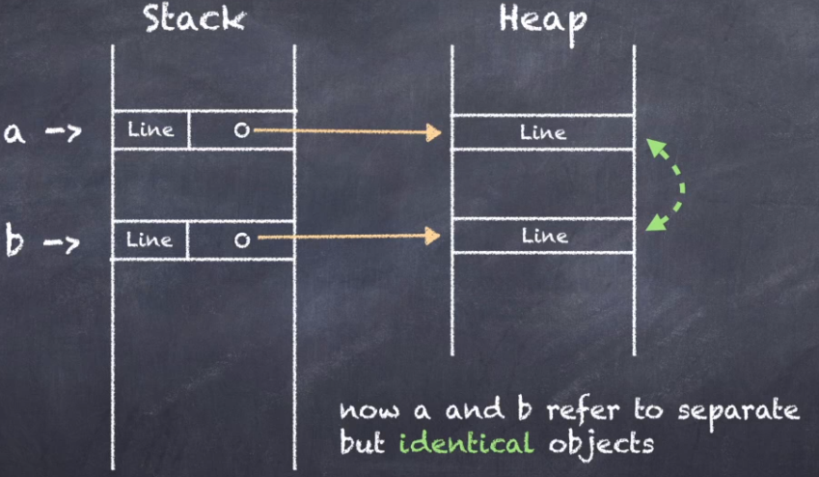

How will the Dot Net Framework interpret this situation?

Check this out. the framework considers these two variables to be not equal.

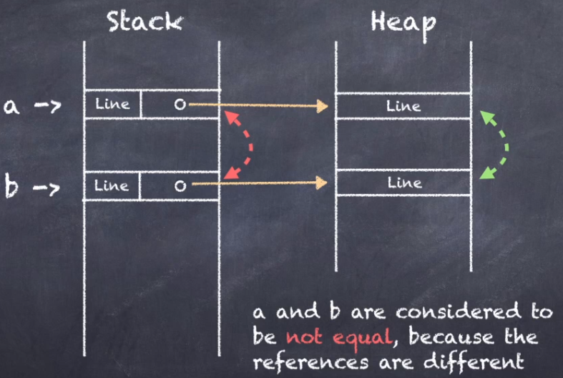

So, this is another important feature of reference type.

They are compared by reference which means two different variables referring to the same objects are considered equal but two different variables referring to two separates but identical objects are considered not equal.

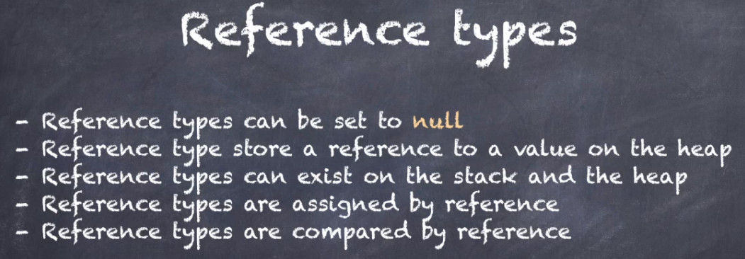

**Lecture: 11. Boxing and Unboxing:**

In C Sharp all types inherit from objects including integers. So, you can put basically everything into an object type variable.

**Example:**

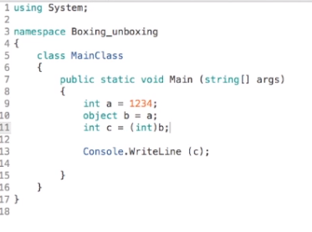

Here is my integer variable A with its value is 1234 And here is my object variable B.

But B is a reference type and we have learnt in the previous lecture that reference types always refer to a value on the heap here.

This is not possible because A is a local variable.

So, it exists on the stack and it's a value type, so its value is also stored on the stack.

There is simply no way for b to refer to A because both variables reside in different types of memory a reference type can never refer to stack memory. So, this program can never work. Well let's find out.

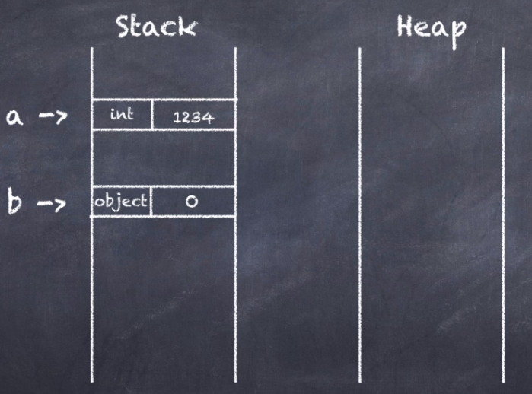

But It works. But how is that possible. This program should not work based on what we learned in previous lectures but yet it does.

Let me decompile this program into Intermediate language (IL). Look at this intermediate language instruction calls box.

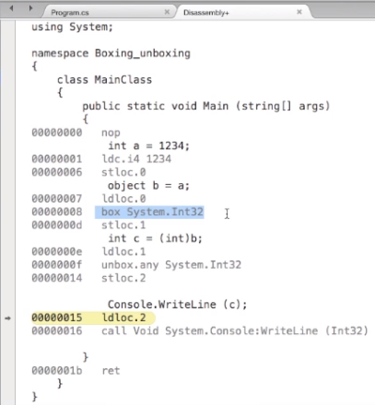

Now the box instruction does this:

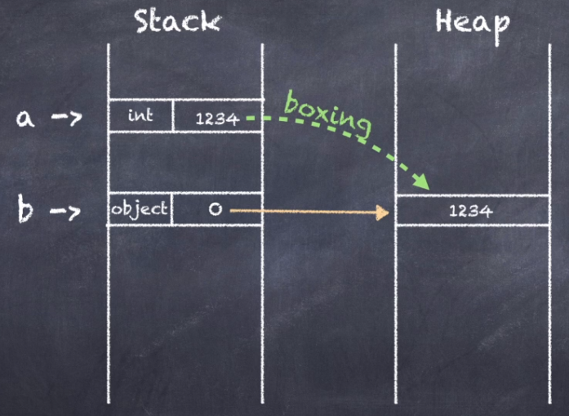

so, to make the program work. The Dot Net framework actually copies the integer value from the stack.

Then packs the value into objects and it places this objects on the heap.

So, the variable b can then refer to it's this whole process is called boxing. Boxing happens every time behind the scenes when you have a viable parameter fields or property of type objects and when assign a value type to it.

Boxing is nice because it’s kind of blurs the line between value types and reference types.

But boxing can also be a pain because it introduces extra overhead in your code.

**Unboxing:**

I declare a variable c of type integer and assign the objects value to it using a typecasts another bit of magic.

Actually, because C exists on the stack and B the objects refers to an object on the heap.

In the intermedius language the corresponding instruction is: It's called Unbox.

Unboxing unpacks the integer on the heap and copies the value back into the variable c on the stack.

Unboxing is the reverse process of boxing.

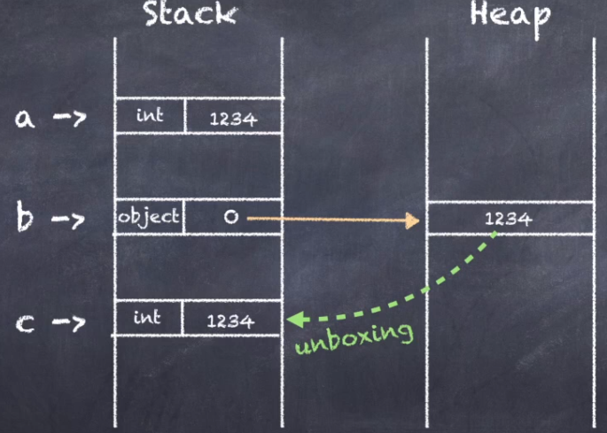

Unboxing happens every time behind the scenes when you have an object value and you cast its to a value type.

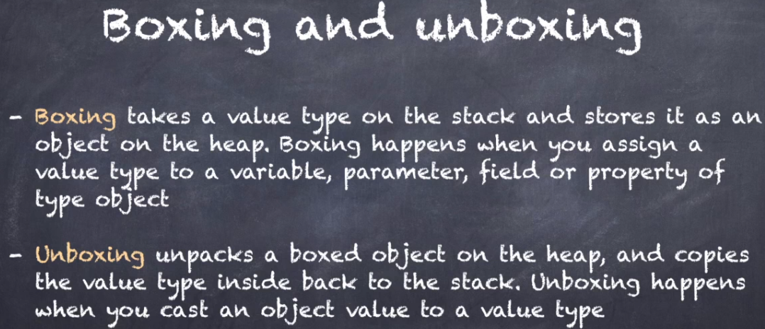

**Lecture 14. Garbage Collection in .NET:**

What happens when reference type variables go out of scope. The variables which exist on the stack are destroyed and the corresponding objects on the heap are dereferenced.

Dereferenced objects continue to exist and are not destroyed immediately. Separate process called the garbage collector periodically cleans up these objects so in this lecture we are going to take a closer look at the garbage collector.

What is the garbage collector and how does it work? Let's starts with a very simple program.

This program only has one method with one local variable an object array. The array is initialized with five objects and these five objects also reside on the heap adjacent to the array itself. Now to make things more interesting let's remove the array elements 2 and 3 by setting their array elements to null the corresponding objects number two and three still exist on the heap.

But now they are dereferenced. There are no references to these objects from anywhere in the code. What happens when the garbage collector kicks in.

The garbage collector is a mark and sweep collect all which means there are two distinct stages of garbage collecting in mark stage and a sweep stage.

**Mark Stage:**

During the mark stage the garbage collector marks all the live objects on the heap.

So, in this example array itself and the objects 0, 1 and 4 marked and the objects 2 and 3 are skipped because there are no references to these objects from anywhere in the code.

**Next comes the sweep stage:**

All objects which have not been marked in the previous stage are dereferenced.

And in this stage, they are deallocated from the heap.

So, in this example the objects 2 and 3 have not been marked and so they are the allocators.

And this leaves a kind of hole on the heap. The dot net garbage collector performs one additional step after the sweep which is called compact.

**Compact Stage:**

In the compact stage all holes on the heap are removed.

So, in this example the object 4 is moved up to fill the hole that objects 2 left behind.

The mark and sweep garbage collector is very good at locating each and every dereferenced object on the heap and remove it.

But it also has a big drawback. It is very slow.

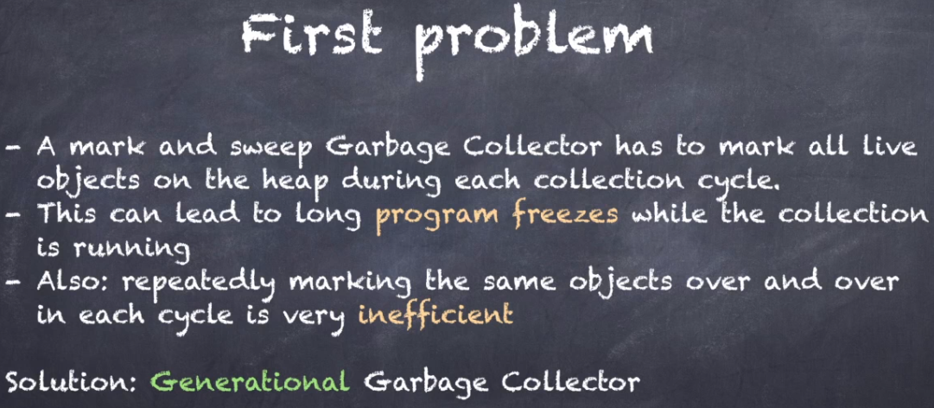

During the mark stage the garbage collector has to inspect each object in memory to determine if it is a live or dereferenced.

If there are many thousands of objects on the heap. Your program will actually freeze for a while as the garbage collector is inspecting each and every object.

The process is also very inefficient because long living objects on the heap are checked and rechecked during each cycle because they could be dereferenced at any time. So, a very long living object might get checked hundreds of times if it is still alive.

The solution to this problem is called a generational garbage collector or the darnedest garbage collector.

**Generational Garbage Collector:**

It has three generations which you can visualize as three separate heaps.

All new allocations go into the first generational heap called Generation Zero.

So, if we revisit the test program with the five elements array with Elements 2 and 3 Set to null then the memory layout would look like this.

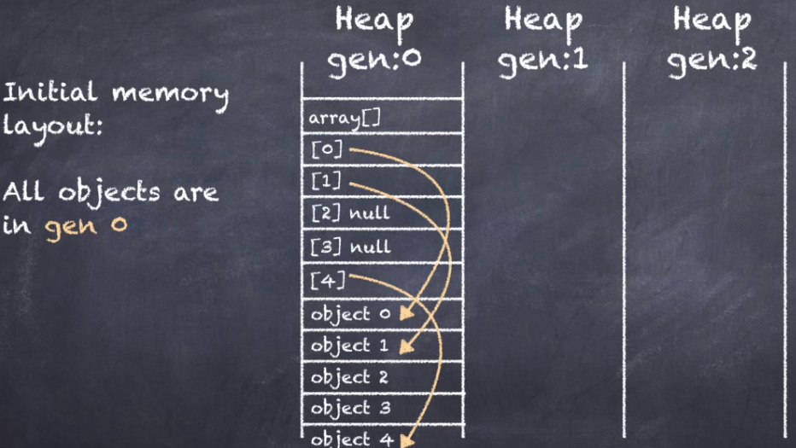

Everything is the same as before but now all objects are residing in Generation Zero generations 1 and 2 are empty.

The first collection cycle does a mark and sweep and all objects that survived the sweep move to generation 1.

So, after one cycle the memory layout looks like this the array and objects 0, 1 and 4 have survived the sweep and are now in Generation 1.

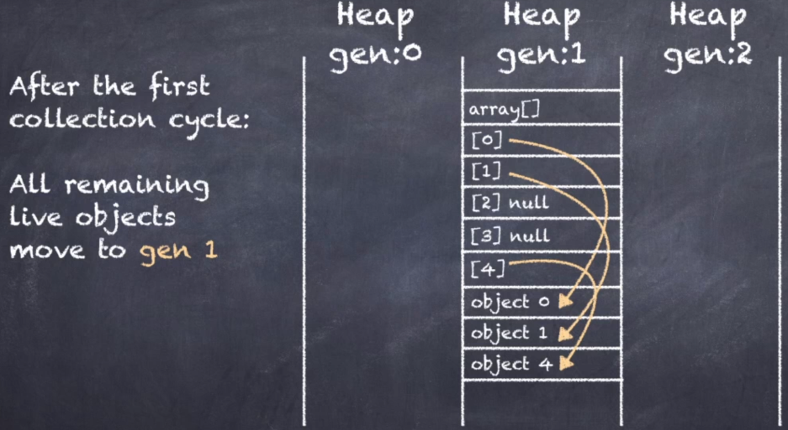

Now imagine that the program continues at this point and puts a new object 5 in array elements. All the new locations go into Generation Zero. So, the memory layout would look like this.

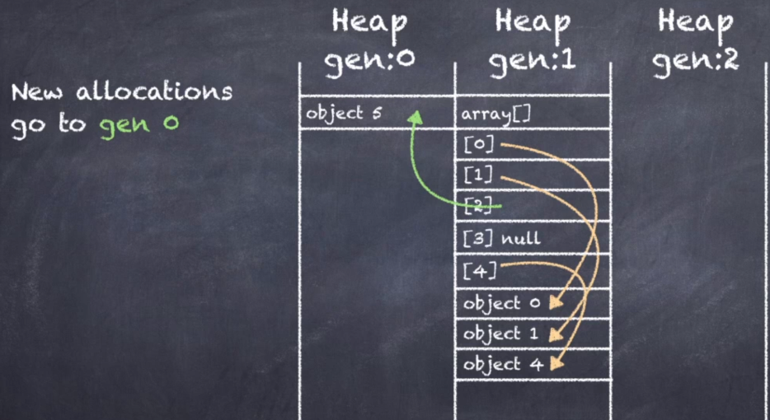

As you see this is an interesting situation. The array resides in Generation 1, but its elements are in generations 0 and 1. This is perfectly valid.

Now the garbage collector kicks in again for a second cycle. All Generation one objects move to generation 2. And the new objects in generation 0 moves to generation 1.

If the program continues and puts a new object 6 in array elements 3 it would again go into generation 0.

We now have an array in Generation 2 referring to objects in generation 0, 1 and 2. Again, perfectly valid.

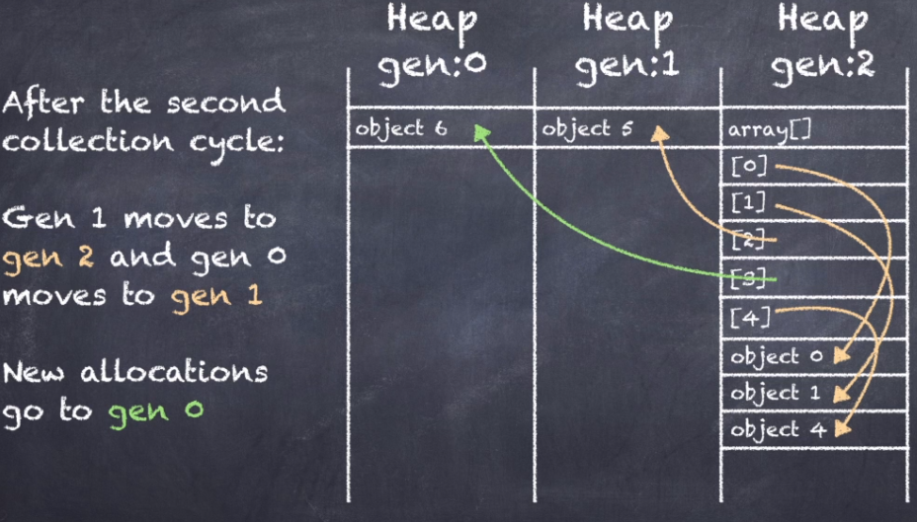

So, you might be wondering at this point why is all this happening. Why have these three generations Well the answer is very simple.

Generations help to limit the number of objects in Generation Zero.

Every collection cycle completely clears Generation Zero of all objects.

So, in the next cycle the garbage collector only has to inspect new objects that were created after the last cycle. of course, the problem isn't going away.

The garbage collector simply moved the objects somewhere else. But here's the key.

Generations 1 and 2 are collected very infrequently.

The garbage collector assumes that anything that reaches generation 2 must be long living objects that does not needs to be checked very often.

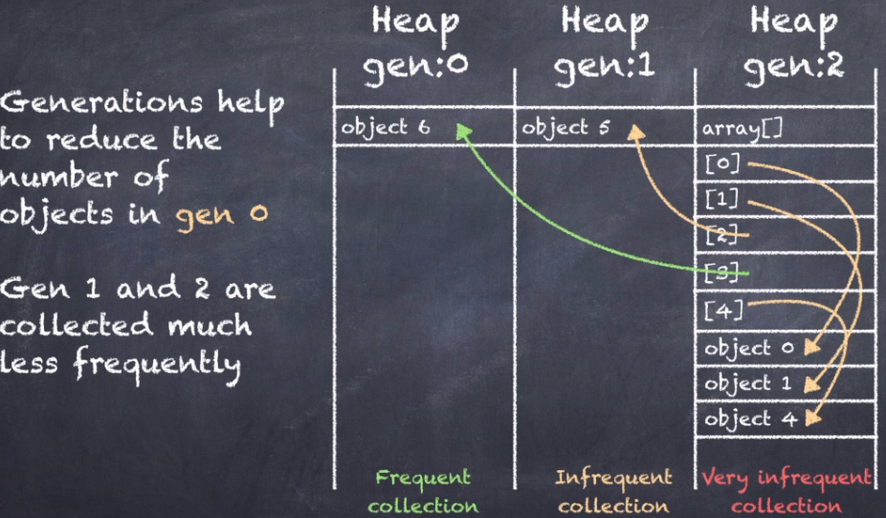

So, this solves two problems. First it reduces the number of objects in Generation Zero.

So, the garbage collector has less work to do. Second long living objects that survive into Generation 2 are not checked very often.

Which is exactly what we want the generational garbage collector is a beautiful high-performance algorithm.

But it has an important drawback. It is inefficient as processing large long living objects.

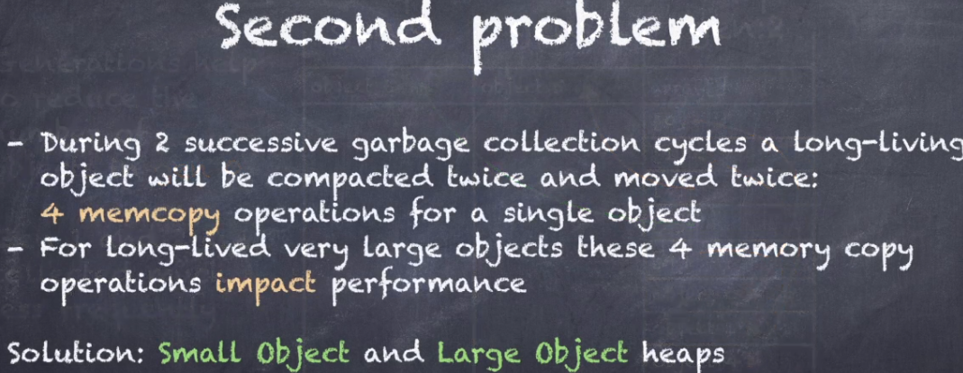

If the object is very large these four copy operations per object can introduce a significant performance overhead.

So, the solution to this problem is to have two separate heaps one for small objects and one for large objects.

The design looks something like this.

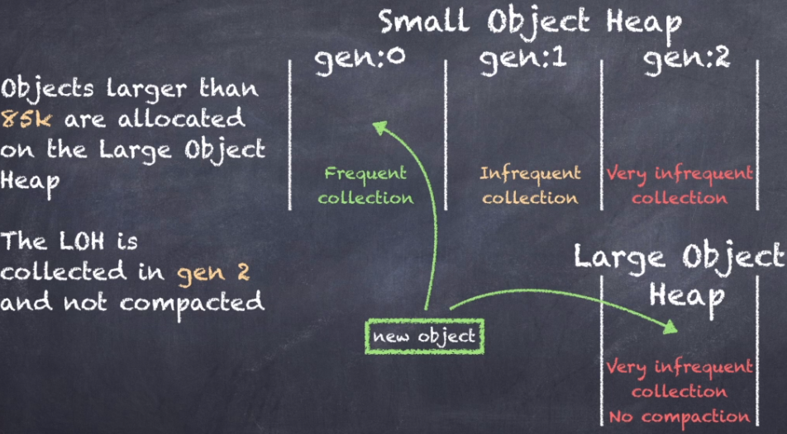

**In .NET there are two heaps:**

* The small object heap which works with the three generations we discussed before.
* The large object heap. The special thing about the large object heap is that it does not use generations. In fact, it has only a single generation which is synchronized with Generation 2 of the small object.
* So, when the garbage collector processes generation 2 of the small object heap it also runs through the entire large object heap.
* Another interesting fact about the large object heap is that it does not compact the app during the sweep cycle.
* It simply merges free memory blocks together. But it does not do any compaction to optimize the total amount of free space.
* You might be wondering what determines if an object is small or large. Well the size threshold is at 85 kilobytes.
* Any objects at 85 kilobytes or larger goes directly to the large object heap. Any object smaller than this limit goes into the small object heap.

Having these two separate heaps solves the problem of large long living objects.

They no longer need to be copied four times before they end up in Generation 2.

But instead they go directly into the large object heap which is only processed in Generation 2 and never compacted.

**GC:**

.NET garbage collector is a generational garbage collector that uses a mark sweep compact cycle and it has separates heaps for large objects and small objects.

.NET GC makes some very specific assumptions about objects and its lifetime.

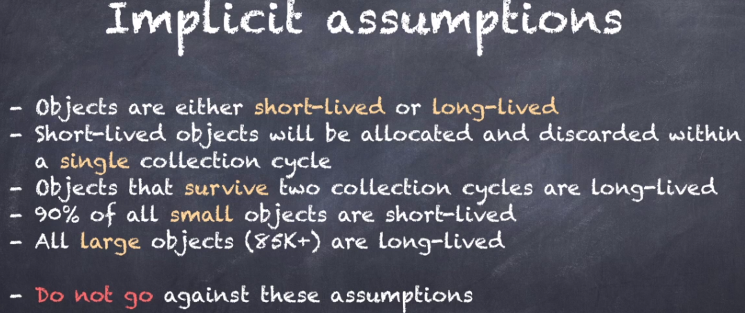

First it assumes objects will either be short lived or long lived. All short-lived objects should be allocated, used and discarded in a single collection cycle.

So, any object that survives two collection cycles ends up in generation two and must be a long living object. (1st point is explained)

**Lecture 15. How to optimize your code for Garbage Collection**

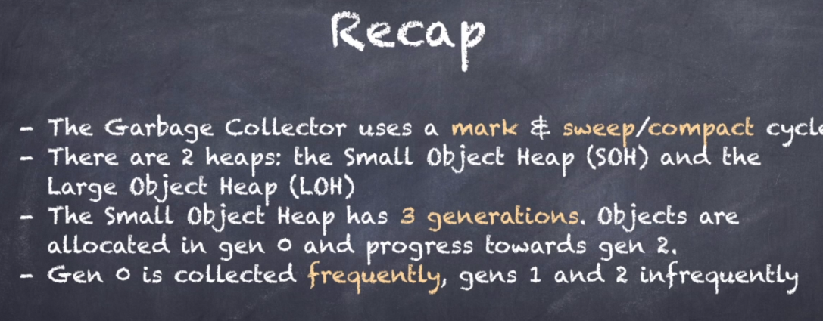

**The first memory-based performance optimization that we are going to look at is to simply limit the number of objects that we create in generation 0.**

* The less objects are created the less work the garbage collector has to do to clean up the heap.
* There are two strategies that you can follow to limit the number of objects on the heap:
* The first is to make sure your code does not create any redundant objects anywhere.
* And second to allocate use and discard your objects as fast as possible so that they are all ready to be deallocated by the garbage collector in the next cycle.
* If you wait too long between allocating, using and discarding your objects you run the risk of ending up them in generations one or two. So, for short lived objects you want your codes to be as tight as possible.



**Let's take a look at some examples.**

**Can you see the problem with this code?**

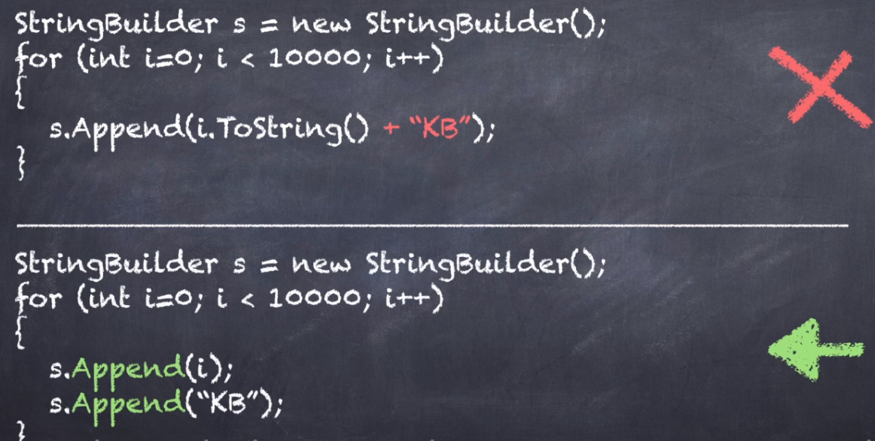

The problem is with the string concatenation inside the appends method. You'll remember that the strings are immutable and so the ToString () method and the addition both creates extra string objects on the heap for every loop iteration.

The code at the bottom avoids this problem by simply calling append twice the difference is 40000 less string objects on the heap. That's a big improvement.

**So, here's another example: See if you can spot the problem.**

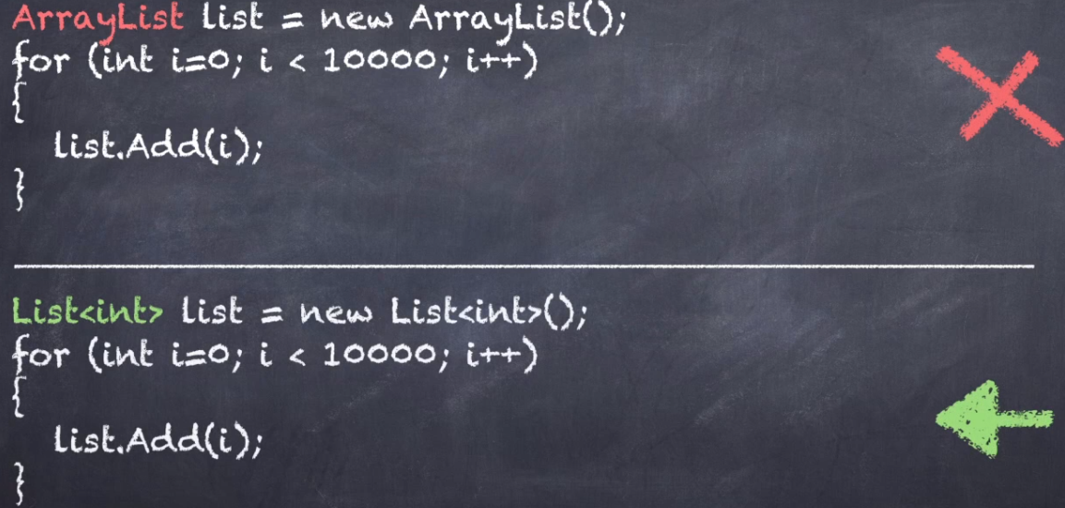

**And here is the solution** if you store integers in an array list the integers get boxed on the heap the. Generic list avoids this problem by using an internal integer array instead of an object array.

A simple modification to the codes that results in 20 thousand less box integer objects on the heap.

**One more example:**

A small static object gets initialized, then lots of other code runs first.

And finally, the object actually gets used. What's wrong with this picture.

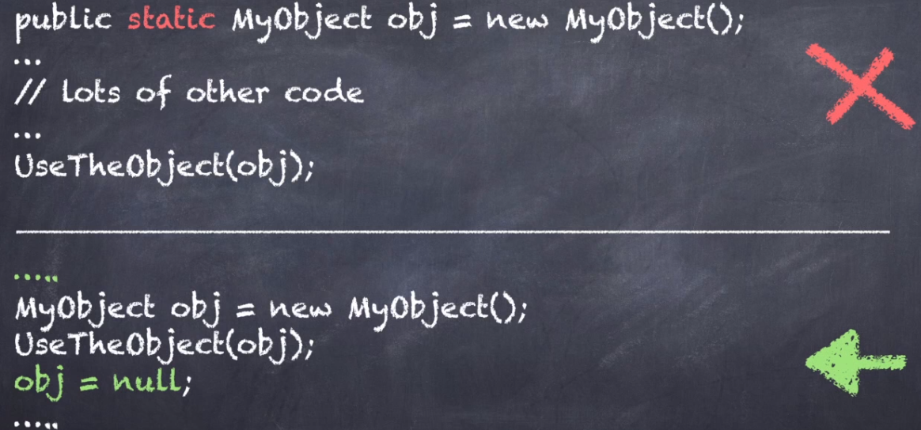

And here is the answer.

* The object is small but the gap between allocation and use is very large. So, there's a big chance the object ends up in generation one or two before it gets used.
* The code at the bottom avoids this problem by first making the objects non-static then allocating it just before use.
* And finally setting the object reference to null right after use to signal to the garbage collection that were done and that the object is ready to be collected.
* If you don't like having null assignments all over your code, you can also wrap the bottom code in a method and have the objects reference go out of scope when you exit the methods.

**The next optimization you can perform is to fine tune the lifetime of your objects:**



GC assumes that's almost all small objects will be short lived, and all large objects will be long lived.

So, we should avoid the opposites, small long-lived objects or large short-lived objects.

It's instructive to view these combinations holograph. If I plot the objects lifetime horizontally and the objects size vertically, I get the following charts.

**16. Finalizers in .NET**

A finalizer is a class method that runs automatically just before an object gets cleaned up by the garbage collector.

Finalizers are also sometimes called destructors to signify that they are the opposites of constructor's whereas a constructor initializes an object and prepares it for first use a destructor does the opposite and cleans up any lingering resources. So, the objects can be discarded.

finalizers are very useful if you allocate scarce resources in your objects for example an operating system file handle.

There are only a limited number of file handles available so it's very important to release the handle when you're done with the object short.

You could implement a close method but what if someone forgets to call it. It's safer to release the file handle in a finalizer so that it is guaranteed to be released when the object is cleaned up.



You might remember this slide with the three generations and the array of objects moving through them.

Let's take another look at the collection process and this time.

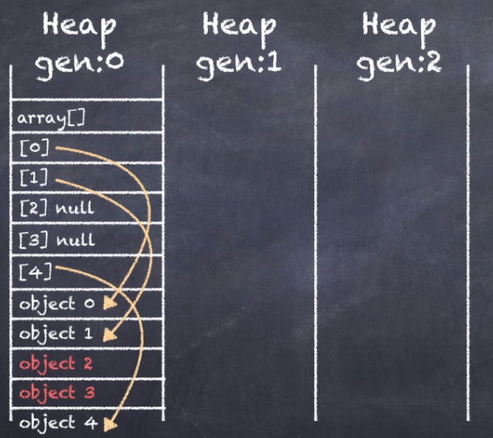

Let's assume that each array element has a finalizer.

So, if we revisit that scenario with Elements 2 and 3 set to null then the memory layouts would look like this.

Everything is the same as before with all objects residing in generation 0. Generations 1 and 2 are empty.

The first collection cycle does a mark and sweep and all objects that survived the sweep move to generation 1.

So, after the first cycle the memory layout looks like this:

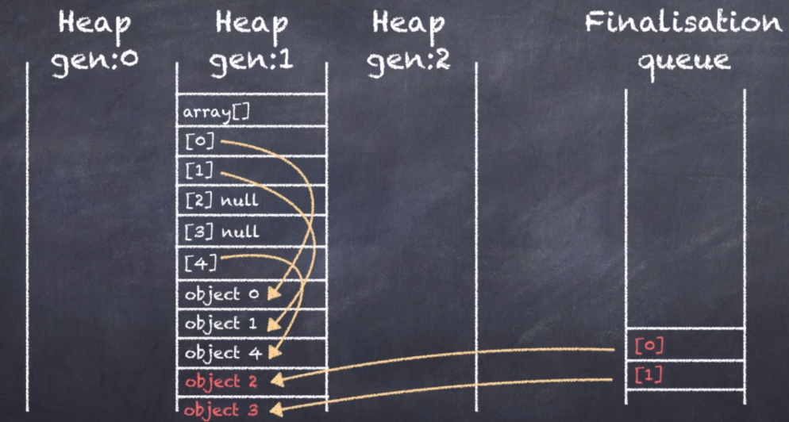

The array and objects 0, 1 and 4 have survived the sweep and are now in Generation 1.

But here is the change objects 2 and 3 are not cleaned up. They can’t be because they have finalizers which still needs to be run so the garbage collector also moves objects 2 and 3 to generation 1 and adds them to a special finalization queue.